Ashvini Krishnan

ASTR 414 HW 2

Netid: akrshnn6

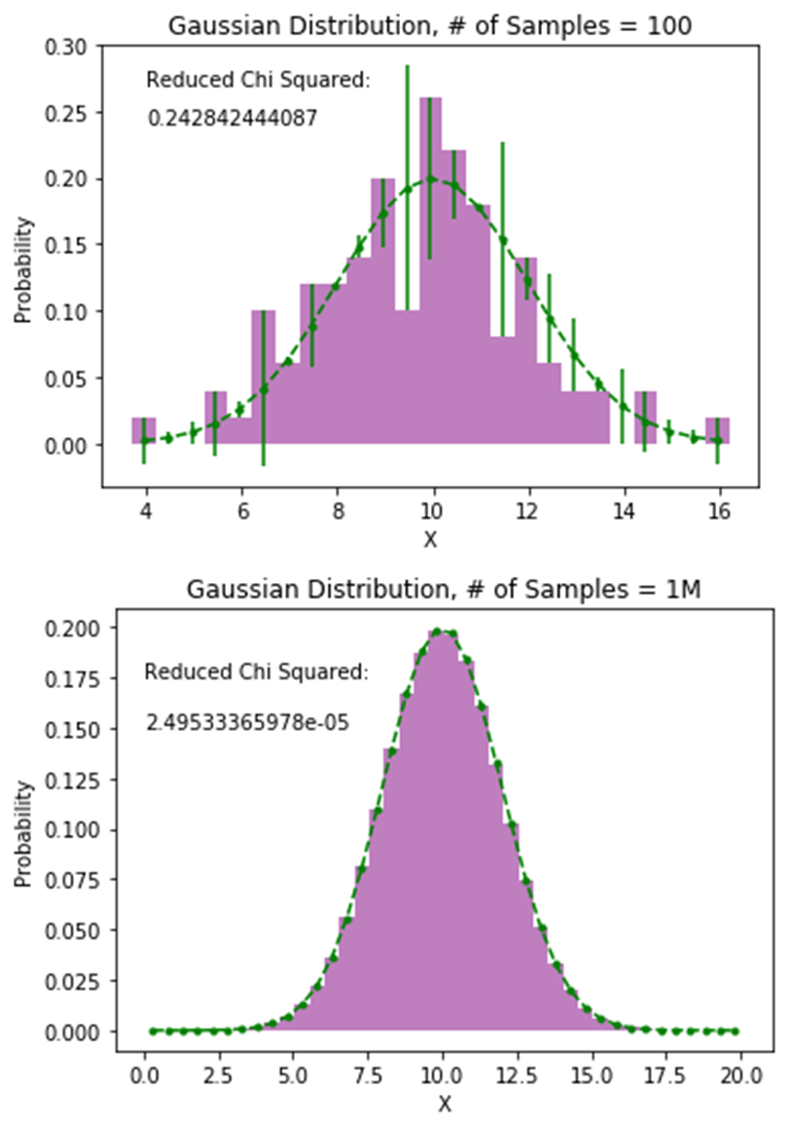Problem 1: Histograms:

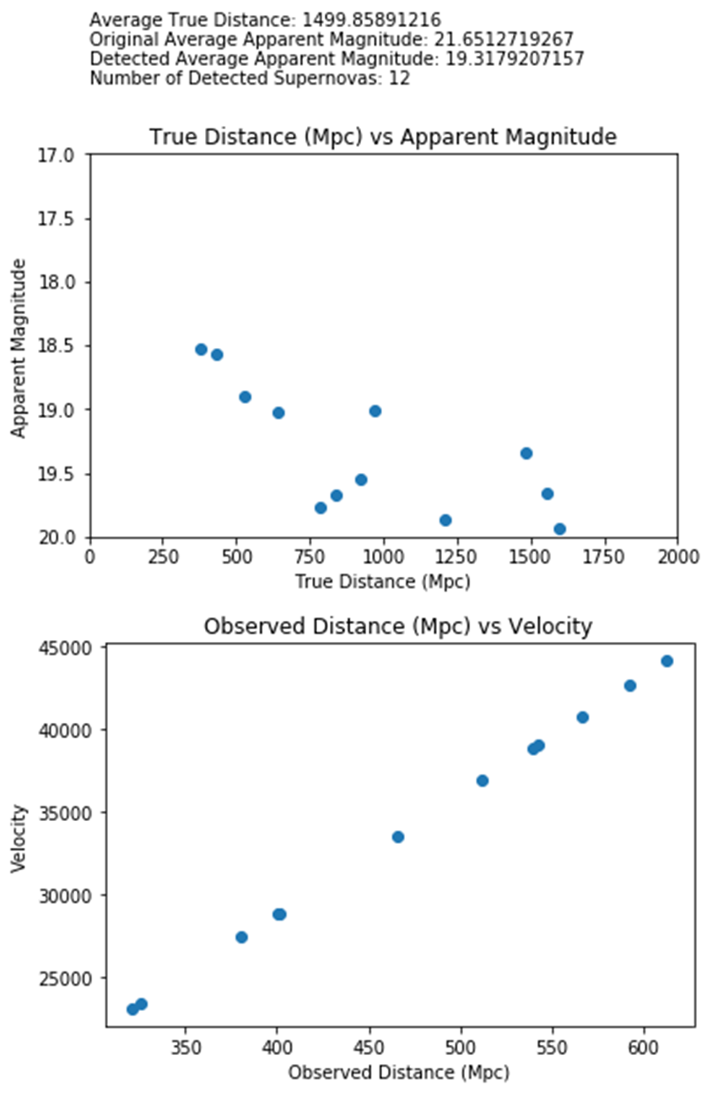Problem 2: Simulated Supernovas

The observing limit causes the distances generated by Hubble’s law, H0V = D to never exceed 1000, despite the true distances of those supernovas often being greater than that limit. In the above distribution of supernovas, all of the observed distances are less than 700 Mpc, despite when looking at the true distance vs apparent magnitude graph for the same supernovas, seven out of twelve detected supernovas are more than 700 Mpc away. The observing limit causes an error of one magnitude when looking at the data.